**JMFK-3 (时间次数控制) V1-1**

**一.实物图**

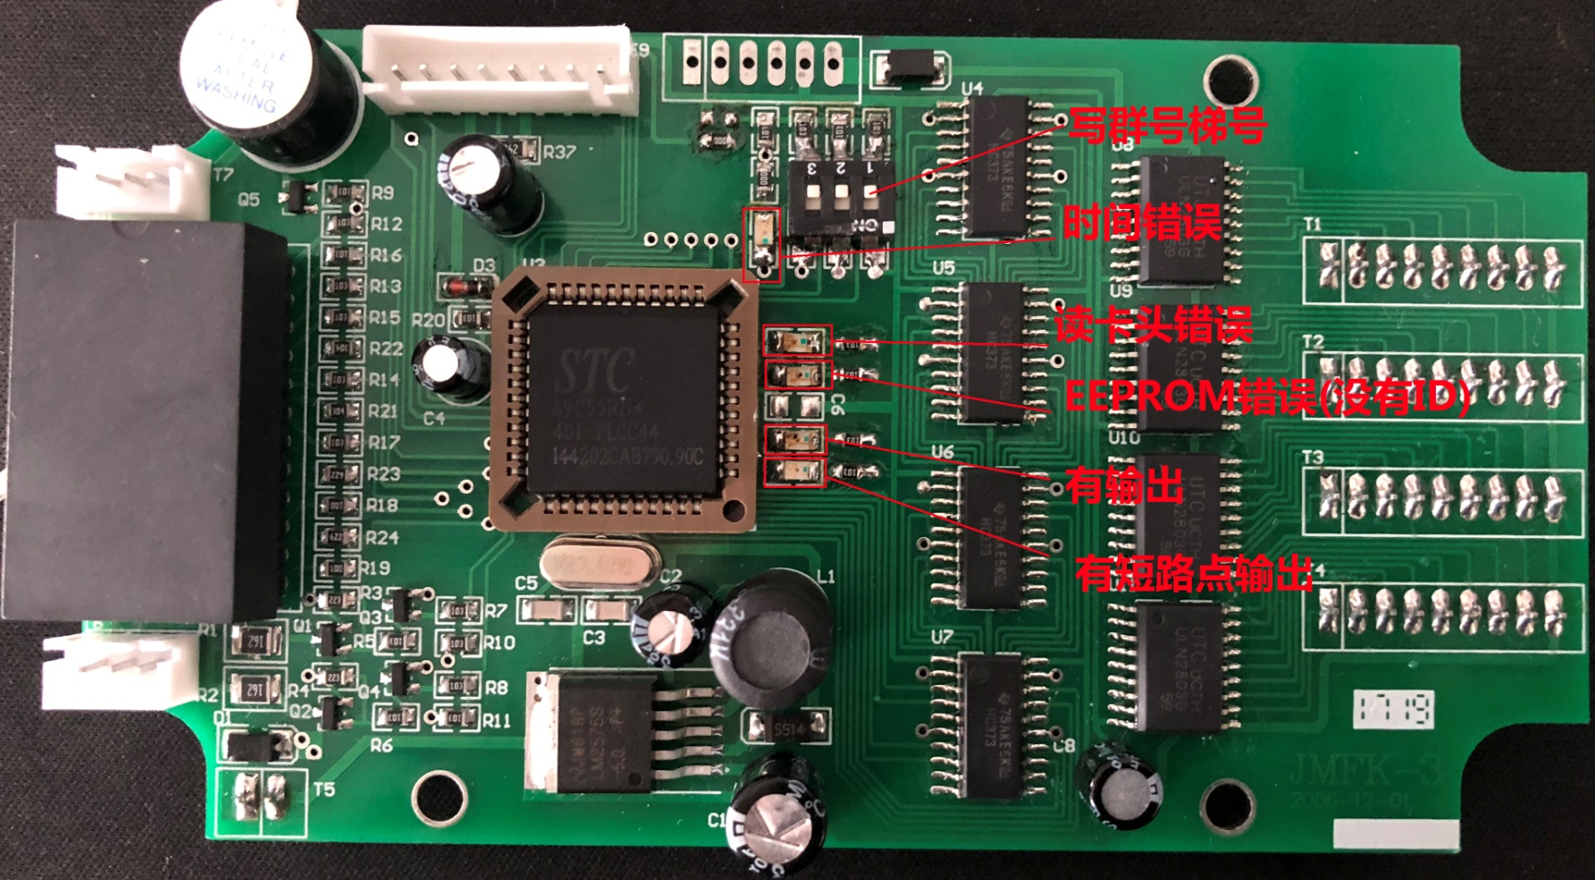

**二.接线图**



**三.c52单片机内存(eeprom):**

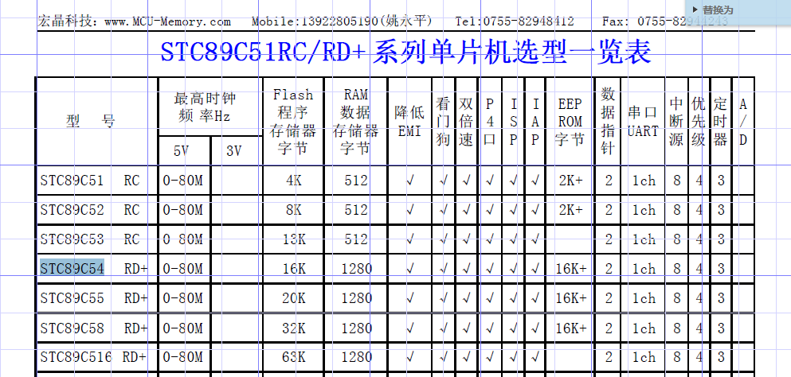  
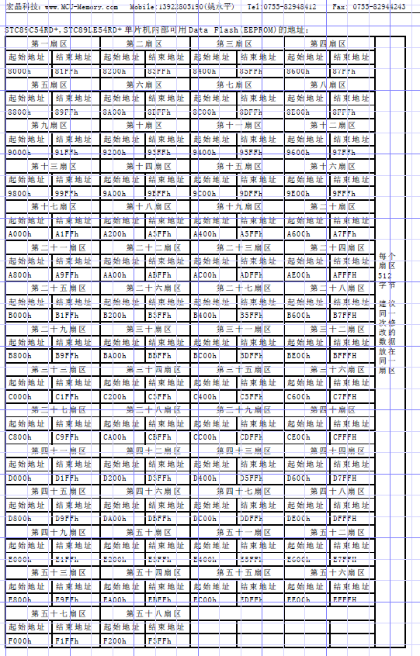

**四.卡数据分布**

|  |  |  |  |  |  |  |  |  |  |  |  |  |  |  |  |  |  |  |
| --- | --- | --- | --- | --- | --- | --- | --- | --- | --- | --- | --- | --- | --- | --- | --- | --- | --- | --- |
| **用户卡:数据格式 [表一]** | | | | | | | | | | | | | | | | | | |
| 扇区号 | 块号 | Byte0 | Byte1 | Byte2 | Byte3 | Byte4 | Byte5 | Byte6 | Byte7 | Byte8 | Byte9 | Byte10 | Byte11 | Byte12 | Byte13 | Byte14 | | Byte15 |
| 0 | BLOCK0 |  |  |  |  |  |  |  |  |  |  |  |  |  |  |  | |  |
| BLOCK1 | 功能 | 群组+梯号 | ID保存的地址序号 | |  |  |  |  |  |  |  |  |  |  |  | |  |
| BLOCK2 | C0 | C1 | C2 | C3 | C4 | C5 | C6 | C7 |  |  |  |  |  |  |  | |  |
| 1 | BLOCK4 | ID | | | | BEGIN-YYMMDD | | | | | | END-YYMMDD | | | | | | |
| BLOCK5 | BEGIN-HHMM | | END-HHMM | | BEGIN-HHMM | | END-HHMM | | BEGIN-HHMM | | END-HHMM | | NUM | | | | |
| BLOCK6 |  |  |  |  |  |  |  |  |  |  |  |  |  |  |  |  | |
| 2 | BLOCK8 |  |  |  |  |  |  |  |  |  |  |  |  |  |  |  |  | |
| BLOCK9 |  |  |  |  |  |  |  |  |  |  |  |  |  |  |  |  | |
| BLOCK10 |  |  |  |  |  |  |  |  |  |  |  |  |  |  |  |  | |
| C0~C7:控制楼层数据;ID:用户的卡的序列号;BEGIN-YYMMMDD:开始日期;END-YYMMDD:结束日期;BEGIN-HHMM:开始时间;END-HHMM:结束时间;  　ID保存的地址序号：此用户的ID存于EEPROM中的位置序号（表三），如：ID=0006,存于EEPROM的地址EC00H, ID保存的地址序号=6784 | | | | | | | | | | | | | | | | | | |

|  |  |  |  |  |  |  |  |  |  |  |  |  |  |  |  |  |  |
| --- | --- | --- | --- | --- | --- | --- | --- | --- | --- | --- | --- | --- | --- | --- | --- | --- | --- |
| **管理卡:数据格式 [表二]** | | | | | | | | | | | | | | | | | |
| 扇区号 | 块号 | Byte0 | Byte1 | Byte2 | Byte3 | Byte4 | Byte5 | Byte6 | Byte7 | Byte8 | Byte9 | Byte10 | Byte11 | Byte12 | Byte13 | Byte14 | Byte15 |
| 0 | BLOCK0 |  |  |  |  |  |  |  |  |  |  |  |  |  |  |  |  |
| BLOCK1 | 功能 |  | EEPROM_ADDR | | ID_num | | 群组+梯号  Group+elevator | 用户卡扇区号  User_section |  |  |  |  |  |  |  |  |
| BLOCK2 | 读写年YY | 读写月mm | 读写日dd | 读写周W | 读写时HH | 读写分MM |  |  | N0 | N1 | N2 | N3 | N4 | N5 | N6 | N7 |
| 1 | BLOCK4 | ID0 | | | | ID1 | | | | ID2 | | | | ID3 | | | |
| BLOCK5 | ID4 | | | | ID5 | | | | ID6 | | | | ID7 | | | |
| BLOCK6 | ID8 | | | | ID9 | | | | ID10 | | | | ID11 | | | |
| 2 | BLOCK8 | ID12 | | | | ID13 | | | | ID14 | | | | ID15 | | | |
| BLOCK9 | ID16 | | | | ID17 | | | | ID18 | | | | ID19 | | | |
| BLOCK10 | ID20 | | | | ID21 | | | | ID22 | | | | ID23 | | | |
| 3 | BLOCK12 | ID24 | | | | ID25 | | | | ID26 | | | | ID27 | | | |
| BLOCK13 | ID28 | | | | ID29 | | | | ID30 | | | | ID31 | | | |
| BLOCK14 | ID32 | | | | ID33 | | | | ID34 | | | | ID35 | | | |
| 4 | BLOCK16 | ID36 | | | | ID37 | | | | ID38 | | | | ID39 | | | |
| BLOCK17 | ID40 | | | | ID41 | | | | ID42 | | | | ID43 | | | |
| BLOCK18 | ID44 | | | | ID45 | | | | ID46 | | | | ID47 | | | |
| 5 | BLOCK20 | ID48 | | | | ID49 | | | | ID50 | | | | ID51 | | | |
| BLOCK21 | ID52 | | | | ID53 | | | | ID54 | | | | ID55 | | | |
| BLOCK22 | ID56 | | | | ID57 | | | | ID58 | | | | ID59 | | | |
| 6 | BLOCK24 | ID60 | | | | ID61 | | | | ID62 | | | | ID63 | | | |
| BLOCK25 | ID64 | | | | ID65 | | | | ID66 | | | | ID67 | | | |
| BLOCK26 | ID68 | | | | ID69 | | | | ID70 | | | | ID71 | | | |
| 7 | BLOCK28 | ID72 | | | | ID73 | | | | ID74 | | | | ID75 | | | |
| BLOCK29 | ID76 | | | | ID77 | | | | ID78 | | | | ID79 | | | |
| BLOCK30 | ID80 | | | | ID81 | | | | ID82 | | | | ID83 | | | |
| 8 | BLOCK32 | ID84 | | | | ID85 | | | | ID86 | | | | ID87 | | | |
| BLOCK33 | ID88 | | | | ID89 | | | | ID90 | | | | ID91 | | | |
| BLOCK34 | ID92 | | | | ID93 | | | | ID94 | | | | ID95 | | | |
| 9 | BLOCK36 | ID96 | | | | ID97 | | | | ID98 | | | | ID99 | | | |
| BLOCK37 | ID100 | | | | ID101 | | | | ID102 | | | | ID103 | | | |
| BLOCK38 | ID104 | | | | ID105 | | | | ID106 | | | | ID107 | | | |
| 10 | BLOCK40 | ID108 | | | | ID109 | | | | ID110 | | | | ID111 | | | |
| BLOCK41 | ID112 | | | | ID113 | | | | ID114 | | | | ID115 | | | |
| BLOCK42 | ID116 | | | | ID117 | | | | ID118 | | | | ID119 | | | |
| 11 | BLOCK44 | ID120 | | | | ID121 | | | | ID122 | | | | ID123 | | | |
| BLOCK45 | ID124 | | | | ID125 | | | | ID126 | | | | ID127 | | | |
| EEPROM-ADDR: eeprom开始地址(例DC00);ID_num:写入的ID数量(例如ID_num=2,写入8 Byte);N0~N7:不需要刷卡的楼层数据;Idxx:用户卡的序列号;不需要刷卡的楼层设置要单独制一张卡;**用户卡序列号第一字节最高位为1表示此序列号已挂失** | | | | | | | | | | | | | | | | | |

|  |  |  |  |  |  |  |  |  |  |
| --- | --- | --- | --- | --- | --- | --- | --- | --- | --- |
| STC89C55RD+的EEPROM扇区1的数据排列 [表五] | | | | | | | | |  |
| 8000h | 8001h | 8002h | 8003h | 8004h | 8005h | 8006h | 8007h | 8008h | 8009h |
| N0 | N1 | N2 | N3 | N4 | N5 | N6 | N7 | 群组+梯号  Group+elevator | User_section扇区号（写入刷卡器eeprom） |
| 备注:  只有管理卡（其它都为0）： 硬件开关1 OFF:写 短路点N0~N7;  硬件开关1 ON:写 群组+梯号、用户卡扇区号、短路点N0~N7; | | | | | | | | |  |

|  |  |  |  |  |  |  |  |  |  |  |  |
| --- | --- | --- | --- | --- | --- | --- | --- | --- | --- | --- | --- |
| STC89C55RD+的EEPROM存储数据 [表三] | | | | | | | | | | | |
| 扇区 | 开始地址 | 结束地址 | | 开始ID | | 结束ID | | 说明 | | | |
| 0 | 8000H | 81ffH | | N0~N7，Group+elevator，User_section | | | | 不用刷卡的楼层数据，群号梯号，扇区号配置, 见表[五] | | | |
| 1 | 8200H | 83ffH | | ID0 | | ID127 | | 用户卡的序列号存放位置 | | | |
| 2 | 8400H | 85ffH | | ID128 | | ID255 | |
| 3 | 8600H | 87ffH | | ID256 | | ID383 | |
| 4 | 8800H | 89ffH | | ID384 | | ID511 | |
| 5 | 8A00H | 8BffH | | ID512 | | ID639 | |
| 6 | 8C00H | 8DffH | | ID640 | | ID767 | |
| 7 | 8E00H | 8FffH | | ID768 | | ID895 | |
| 8 | 9000H | 91ffH | | ID896 | | ID1023 | |
| 9 | 9200H | 93ffH | | ID1024 | | ID1151 | |
| 10 | 9400H | 95ffH | | ID1152 | | ID1279 | |
| 11 | 9600H | 97ffH | | ID1280 | | ID1407 | |
| 12 | 9800H | 99ffH | | ID1408 | | ID1535 | |
| 13 | 9A00H | 9BffH | | ID1536 | | ID1663 | |
| 14 | 9C00H | 9DffH | | ID1664 | | ID1791 | |
| 15 | 9E00H | 9FffH | | ID1792 | | ID1919 | |
| 16 | A000H | A1ffH | | ID1920 | | ID2047 | |
| 16 | A200H | A3ffH | | ID2048 | | ID2175 | |
| 17 | A400H | A5ffH | | ID2176 | | ID2303 | |
| 19 | A600H | A7ffH | | ID2304 | | ID2431 | |
| 20 | A800H | A9FFH | | ID2432 | | ID2559 | |
| 21 | AA00H | ABFFH | | ID2560 | | ID2687 | |
| 22 | AC00H | ADFFH | | ID2688 | | ID2815 | |
| 23 | AE00H | AFFFH | | ID2816 | | ID2943 | |
| 24 | B000H | B1ffH | | ID2944 | | ID3071 | |
| 25 | B200H | B3ffH | | ID3072 | | ID3199 | |
| 26 | B400H | B5ffH | | ID3200 | | ID3327 | |
| 27 | B600H | B7ffH | | ID3328 | | ID3455 | |
| 28 | B800H | B9FFH | | ID3456 | | ID3583 | |
| 29 | BA00H | BBFFH | | ID3584 | | ID3711 | |
| 30 | BC00H | BDFFH | | ID3712 | | ID3839 | |
| 31 | BE00H | BFFFH | | ID3840 | | ID3967 | |
| 32 | C000H | C1ffH | | ID3968 | | ID4095 | |
| 33 | C200H | C3ffH | | ID4096 | | ID4223 | |
| 34 | C400H | C5ffH | | ID4224 | | ID4351 | |
| 35 | C600H | C7ffH | | ID4352 | | ID4479 | |
| 36 | C800H | C9FFH | | ID4480 | | ID4607 | |
| 37 | CA00H | CBFFH | | ID4608 | | ID4735 | |
| 38 | CC00H | CDFFH | | ID4736 | | ID4863 | |
| 39 | CE00H | CFFFH | | ID4864 | | ID4991 | |
| 40 | D000H | D1ffH | | ID4992 | | ID5119 | |
| 41 | D200H | D3ffH | | ID5120 | | ID5247 | |
| 42 | D400H | D5ffH | | ID5248 | | ID5375 | |
| 43 | D600H | D7ffH | | ID5376 | | ID5503 | |
| 44 | D800H | D9FFH | | ID5504 | | ID5631 | |
| 45 | DA00H | DBFFH | | ID5632 | | ID5759 | |
| 46 | DC00H | DDFFH | | ID5760 | | ID5887 | |
| 47 | DE00H | DFFFH | | ID5888 | | ID6015 | |
| 48 | E000H | E1ffH | | ID6016 | | ID6143 | |
| 49 | E200H | E3ffH | | ID6144 | | ID6271 | |
| 50 | E400H | E5ffH | | ID6272 | | ID6399 | |
| 51 | E600H | E7ffH | | ID6400 | | ID6527 | |
| 52 | E800H | E9FFH | | ID6528 | | ID6655 | |
| 53 | EA00H | EBFFH | | ID6656 | | ID6783 | |
| 54 | EC00H | EDFFH | | ID6784 | | ID6911 | |
| 55 | EE00H | EFFFH | | ID6912 | | ID7039 | |
| 56 | F000H | F1ffH | | ID7040 | | ID7167 | |
| 57 | F200H | F3ffH | | ID7168 | | ID7295 | |
| JMFK-3时间型读卡器卡的位数据 [表四] | | | | | | | | | | | | | | | | |
| 卡数据 | | | | | BIT位 | | | | | | | | | | | 备 注 |
| 卡的块号 | | | 数据 | | B7 | | B6 | | B5 | B4 | B3 | | B2 | B1 | B0 | 位 |
| BLock1 | | | byte0 | | 卡的功能 | | | | | | | | | | | (见表六) |
| byte1 | | Group群组号（0~7,0全部) | | | | | Elevator梯号（0~31,0全部） | | | | | | 电梯选择 |
| byte2 | | EEPROM_ADDR_H | | | | | | | | | | | 见表[二]  (管理卡,写ID用) |
| byte3 | | EEPROM_ADDR_L | | | | | | | | | | |
| byte4 | | Byte_num_H | | | | | | | | | | |
| byte5 | | Byte_num_L | | | | | | | | | | |
| BLock2 | | | byte0 | | C0_7 | | C0_6 | | C0_5 | C0_4 | C0_3 | | C0_2 | C0_1 | C0_0 | C0~C3的位数据[表一]，为1对应点受刷卡器控制，为0对应点不受刷卡器控制 |
| byte1 | | C1_7 | | C1_6 | | C1_5 | C1_4 | C1_3 | | C1_2 | C1_1 | C1_0 |
| byte2 | | C2_7 | | C2_6 | | C2_5 | C2_4 | C2_3 | | C2_2 | C2_1 | C2_0 |
| byte3 | | C3_7 | | C3_6 | | C3_5 | C3_4 | C3_3 | | C3_2 | C3_1 | C3_0 |
| byte8 | | N0_7 | | N0_6 | | N0_5 | N0_4 | N0_3 | | N0_2 | N0_1 | N0_0 | N0~N3的位数据[表二]，为1时对应控制点短路（接通，无需刷卡即可用)，为0读卡功能有效（管理用，刷一次，存入单片机） |
| byte9 | | N1_7 | | N1_6 | | N1_5 | N1_4 | N1_3 | | N1_2 | N1_1 | N1_0 |
| byte10 | | N2_7 | | N2_6 | | N2_5 | N2_4 | N2_3 | | N2_2 | N2_1 | N2_0 |
| byte11 | | N3_7 | | N3_6 | | N3_5 | N3_4 | N3_3 | | N3_2 | N3_1 | N3_0 |
| Block4~block62 | | | ID0~ID178 见表[二] | | | | | | | | | | | | | |

**功能(block1-byte0)列表说明(表六)**

|  |  |  |  |  |  |  |  |  |  |  |
| --- | --- | --- | --- | --- | --- | --- | --- | --- | --- | --- |
| 位  功  能 | B7 | B6 | B5 | B4 | B3 | B2 | B1 | B0 | **地址开关1** | 备注 |
| 开关卡 | 管理卡 | 写序列号 | 计次数 | 读时间 | 写时间 | * | * |
| 写短路点 | 0 | 1 | 0 | 0 | 0 | 0 | 0 | 0 | 0 | 表二，表五的数据N0~N7 |
| 写短路点+群组号+扇区号 | 0 | 1 | 0 | 0 | 0 | 0 | 0 | 0 | 1 | 表二，表五的数据N0~N7，Group,Elevatro,User_section |
| 写ID号 | 0 | 1 | 1 | * | * | * | * | * | * | 表二：EEPROM_ADDR，Byte_num，ID0~ID127  表四：EEPROM ID0~ID7295 |
| 写时间 | 0 | 1 | 0 | * | 0 | 1 | * | * | * | 表二:YYmmddWWHHMM |
| 读时间 | 0 | 1 | 0 | * | 1 | 0 | * | * | * | 表二:YYmmddWWHHMM |
| 用户卡 | 0 | 0 | * | * | * | * | * | * | * | 表一 |
| 开关卡 | 1 | 0 | * | * | * | * | * | * | * | 表一 |
|  |  |  |  |  |  |  |  |  |  |  |
|  |  |  |  |  |  |  |  |  |  |  |

**五.程序流程**

